Extension

for

Mr & Mrs Smith
Beaconstone
Hillcommon
Somerset
TA4 1DU

at:

1 Station Road
Ilton
Somerset
TA19 9BZ

Mr & Mrs Smith
Beaconstone
Hillcommon
Somerset
TA4 1DU

Site address:
1 Station Road
Ilton
Somerset
TA19 9BZ

Tuesday, 1st November 2016

Dear Mr & Mrs Smith,

Subject: Extension

Thank you for your valued enquiry and instructions to quote for the above project.

We are pleased to attach the following estimate as requested. Should you have any questions regarding this estimate, please do not hesitate to contact us.

Considerations:

This estimate is based on the specification described herein. Any changes to drawings or specification would be treated as a variation and may be subject to an agreed price adjustment.

This estimate is valid for a period of 28 days from date of issue.

We trust that we have interpreted your requirements correctly as every effort has been made to accurately estimate your project.

We look forward to hearing from you.

Yours sincerely

P. Harris

Site set up  Set up site ready to commence building works. Provide site toilet, cabin and security fencing to protect the building works during construction. Ensure the provision of adequate health and safety documentation and insurance for the duration of the contract. | 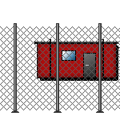

Labour

Sundry
Site Establishment
Set up Site | General Labourer | 8 Hours

Plant

Sundry
Site Establishment (Sundry Plant)
Mixer | Mixer 4/3 Petrol or Electric | 6 Week

Total Cost Excluding VAT £384.80

Brickwork Shell  Construct facing brick in sand/cement mortar, leaving all joints with recessed finish. All openings around windows, doors etc. to be provided with vertical damp proof courses where required. Internal leaf to be formed in blockwork. | 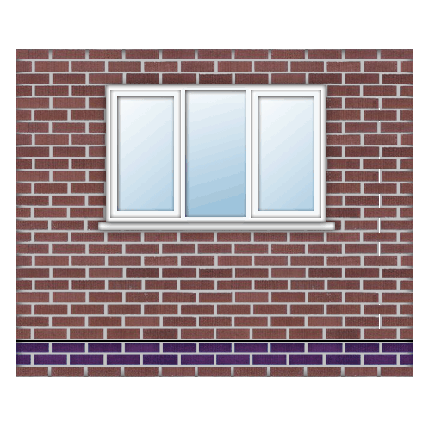

Material

Extension
External Cavity Block Wall (external walls)
Outer leaf blocks above dpc less openings | Solid Dense Concrete Block 7N 440 x 215 x 100mm | 37 m²
Inner leaf blocks above dpc less openings | Insulation Block Standard 440 x 215 x 100mm | 37 m²
Cavity Insulation to cavity blockwalls | Cavity Wall Insulation 100 x 455 x 1200mm 10 Sheets 5.46m2 | 6.7 Each
Brick ties to cavity blockwalls | Brickwork Tie DD140 Type 4 225mm | 110 Each
Sand above dpc in outer blockwork | Building Sand Bulk Bag | 0.53 Each
Sand above dpc in inner blockwork | Building Sand Bulk Bag | 0.53 Each
Cement above dpc in outer blockwork | Blue Circle Mastercrete Original Cement 25kg Bag | 3 Each
Cement above dpc in inner blockwork | Blue Circle Mastercrete Original Cement 25kg Bag | 3 Each

House
Brick and Block Cavity Wall (ext. walls)
Bricks above dpc less openings | Facing Bricks - Provisional (Allowance £0.60 each) | 288 Each
Blocks above dpc less openings | Insulation Block Standard 440 x 215 x 100mm | 4.8 m²
Cavity Insulation | Polyisocyanurate Insulation Board 1200 x 450 x 50mm | 8.9 Sheet
Brick ties | Brickwork Tie DD140 Type 4 225mm | 14 Each
Insulation retaining clips | Insulation Retaining Clip | 14 Each
Sand above dpc in brickwork | Building Sand Bulk Bag | 0.22 Each
Sand above dpc in blockwork | Building Sand Bulk Bag | 0.07 Each
Cement above dpc in brickwork | Blue Circle Mastercrete Original Cement 25kg Bag | 1.2 Each
Cement above dpc in blockwork | Blue Circle Mastercrete Original Cement 25kg Bag | 0.4 Each
PVCu Windows 1050 Deep (110 C 600 x 1050 window)
Vertical DPC to sides of window | Pitch Polymer DPC 150mm x 20m | 0.13 Each
External/Combination lintel | Steel Lintel 100 mm Cavity x 900mm | 1 Each
Dummy frame timber | Sawn Softwood Kiln Dried 47.0 x 75mm | 3.3 Metre
Cavity closure | Cavity Closer 100mm x 3m | 1 Each
PVCu Windows 1200 Deep (212C 1200 x 1200 window)
Vertical DPC to sides of window | Pitch Polymer DPC 150mm x 20m | 0.14 Each
External/Combination lintel | Steel Lintel 100 mm Cavity x 1500mm | 1 Each
Dummy frame timber | Sawn Softwood Kiln Dried 47.0 x 75mm | 4.8 Metre
Cavity closure | Cavity Closer 100mm x 3m | 1 Each

Labour

Extension
External Cavity Block Wall (external walls)
Lay outer blockwork above dpc | 2 Bricklayers and Mate | 12 Hours
Lay inner blockwork above dpc | 2 Bricklayers and Mate | 12 Hours
Fix cavity Insulation to cavity blockwork | 2 Bricklayers and Mate | 2 Hours
Lean To Roof (lean to roof)
Fix Lean to roof cavity tray | Bricklayer | 10 Hours

House
Brick and Block Cavity Wall (ext. walls)
Lay bricks above dpc less openings | 2 Bricklayers and Mate | 3 Hours
Lay blocks above dpc less openings | 2 Bricklayers and Mate | 2 Hours
Fix cavity Insulation | 2 Bricklayers and Mate | 1 Hours
remove brick corbel and reinstate | Bricklayer and Labourer | 5 Hours
PVCu Windows 1050 Deep (110 C 600 x 1050 window)
Form dummy frame | Joiner | 1 Hours
Form opening | Bricklayer | 1 Hours
Fix vertical DPC/ Cavity closure | Bricklayer | 1 Hours
Fix external lintel | Bricklayer | 1 Hours
Fix preformed cavity tray | Bricklayer | 1 Hours
PVCu Windows 1200 Deep (212C 1200 x 1200 window)
Form dummy frame | Joiner | 1 Hours
Form opening | Bricklayer | 1 Hours
Fix vertical DPC/ Cavity closure | Bricklayer | 1 Hours
Fix external lintel | Bricklayer | 1 Hours
Fix preformed cavity tray | Bricklayer | 1 Hours

Total Cost Excluding VAT £4,887.98

Demolition

An allowance has been made to carry out the demolition works as described. All demolition material to be either removed from site or recycled where possible. All demolition material becomes the property of the contractor.

Labour

Extension

(remove existing roof)
Labour | General Labourer | 32 Hours
Removal of Plaster Ceilings (remove ceilings)
Labour to remove plaster from ceiling | General Labourer | 9 Hours

Plant

Extension
(remove existing roof)
Wheel barrow | Wheelbarrow | 0.4 Week
Shovel | Shovel | 0.4 Week
Removal of debris from site | Skip 7m3 inc. Land Fill Tax | 0.54 Each
Plant delivery and collection | Delivery (10 to 15 Miles) | 2 Each
Removal of Plaster Ceilings (remove ceilings)
Wheel barrow for removal of plaster | Wheelbarrow | 0.2 Week
Shovel for removal of plaster | Shovel | 0.2 Week
Removal of debris from site | Skip 7m3 inc. Land Fill Tax | 0.12 Each

Total Cost Excluding VAT £924.40

Erect Scaffold  Erect scaffolding on site to provide access for our contractors. No allowance has been made to adapt the scaffolding for clients or their own contractors' requirements. | 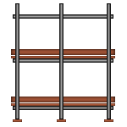

Subcontract Work

Extension
Scaffolding (scaffold)
Scaffold budget | Scaffolding contractor | 705 Unit

Subcontract Work

Extension
Scaffolding (scaffold)
Allowance for sundry costs | Sundry Costs | 50 Each

Total Cost Excluding VAT £981.50

First Floor Joists  Fix all joists and trimmers as required. |  | 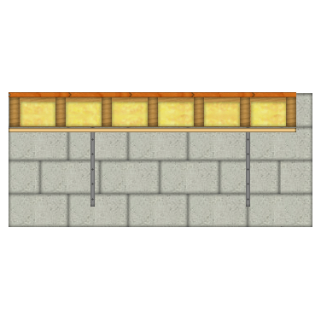

Material

Extension
Suspended Floor (suspended floor)
Floor joists | Sawn Dry Graded Structural Softwood Treated 47.0 x 200mm |  | 43 Metre
Floor joist straps | Lateral Restraint Strap 30 x 5 x 1200mm bent at 150mmm |  | 2 Each
Floor joist hangers | Joist Hanger 50mm Standard Leg |  | 17 Each
Floor joist boots | Joist Boot |  | 17 Each
Floor trimmer No 1 | Sawn Dry Graded Structural Softwood Treated 75.0 x 200mm |  | 6.4 Metre
Nailing allowance to floor structure | Round Wire Nails Bright 100mm x 25kg |  | 0.25 Box

Labour

Extension
Suspended Floor (suspended floor)
Fix floor joists | Joiner + Mate |  | 2 Hours
Fix floor joist hangers | Joiner |  | 2 Hours
Fix joist boots | Joiner + Mate |  | 1 Hours
Fix floor joist straps | Joiner |  | 1 Hours
Fix floor trimmer No 1 | Joiner + Mate |  | 2 Hours

Total Cost Excluding VAT £908.29

Roof Structure  Form roof structure including any fascia’s and bargeboards and associated guttering as described. | 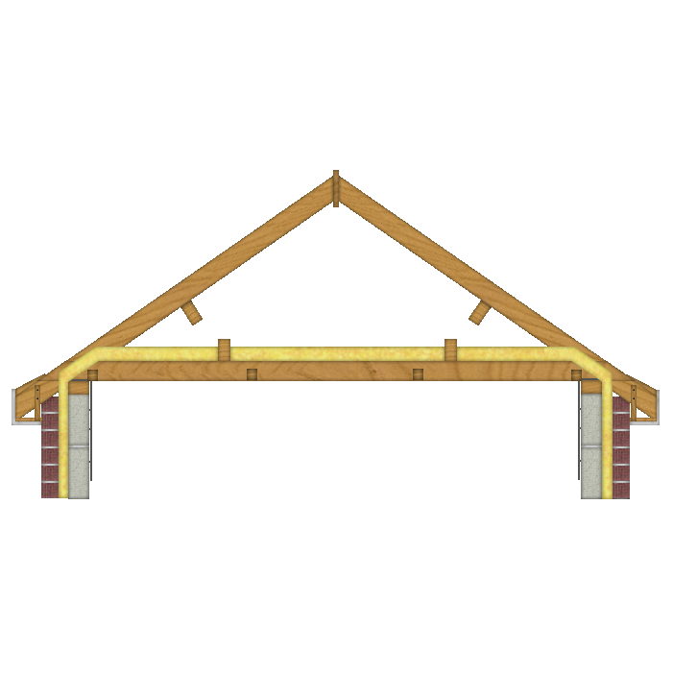

Material

Extension
Apex Truss Roof (Main roof)
Noggings between roof joists | Sawn Softwood Kiln Dried Treated 47.0 x 50mm | 15 Metre
Apex truss roof rafters | Stepped Roof Trusses, 6350 mm span Treated (Allowance £50) | 5 Each
Truss Clips | Truss Clip 50mm | 10 Each
Soffit carriers | Sawn Batten Treated 25.0 x 38mm | 2 Metre
Wall plate | Sawn Dry Graded Structural Softwood Treated 47.0 x 100mm | 5.3 Metre
Diagonal bracing | Sawn Dry Graded Structural Softwood Treated 25.0 x 100mm | 10 Metre
Longitudinal bracing | Sawn Dry Graded Structural Softwood Treated 25.0 x 100mm | 9.4 Metre
Apex bracing | Sawn Dry Graded Structural Softwood Treated 25.0 x 100mm | 2.4 Metre
Roof structure fixings (allowance) | Round Wire Nails Bright 100mm x 25kg | 0.24 Box
Eaves fascia | White 175mm Square Fascia x 16mm x 5.0M | 1.1 Each
Tilting fillets | Sawn Firring Treated 47.0 x 50mm (2 Pack) | 2.5 Metre
Tilting fillet support board | Cement Soffit Strip 2400 x 150 x 4.5mm | 2.2 Each
Eaves ventilator | Soffit Vent 2440mm (For 6-10mm soffit board) | 2.2 Each
Eaves ventilator fixings | Wood Screws Steel CSK Twin Thread 6 x 0.75 inch (200 box) | 0.13 Box
Wallplate straps | Lateral Restraint Strap 30 x 5 x 1200mm bent at 150mmm | 4 Each
Gable straps at joist level | Lateral Restraint Strap 30 x 5 x 1200mm bent at 150mmm | 6 Each
Gable straps at verge level | Lateral Restraint Strap 30 x 5 x 1600mm bent at 100mmm | 8 Each
Eaves soffits (side 1) | White 400mm PVC Board x 9mm x 5.0M | 0.27 Each
Eaves soffits (side 2) | White 400mm PVC Board x 9mm x 5.0M | 0.27 Each
Soffit fixings | White plastic top Nail 40mm - 10G (100 box) | 0.21 Each
Gutter | Plastic Half Round Gutter 4m x 112mm | 1.4 Each
Down pipe | Plastic Round Downpipe 4m x 68mm | 2 Each
Stop ends | Plastic Half Round Gutter Stop End External 112mm | 4 Each
Gutter clips | Plastic Half Round Gutter Support Bracket 112mm | 8 Each
Gutter outlet | Plastic Half Round Gutter Running Outlet 68mm Downpipe | 2 Each
Down pipe clips | Plastic Round Downpipe Bracket 68mm | 6 Each
Swan necks | Plastic Round Downpipe Bend 68mm | 4 Each
Lean to Roof
Lean to roof joists | Regularised Joist Kiln Dried C16 Graded 47.0 x 125mm | 5.6 Metre
Noggings between roof joists | Sawn Softwood Kiln Dried Treated 47.0 x 50mm | 4.9 Metre
Lean to roof rafters | Regularised Joist Kiln Dried C16 Graded 47.0 x 125mm | 11 Metre
Noggings between rafters | Sawn Softwood Kiln Dried Treated 47.0 x 50mm | 4.9 Metre
Soffit carriers | Sawn Batten Treated 25.0 x 38mm | 2.4 Metre
Lean to roof eaves wall plate | Sawn Dry Graded Structural Softwood Treated 47.0 x 100mm | 3 Metre
Lean to roof eaves wall plate fixings | Hammer in Fixing 8mm x 100mm (12 Bag) | 0.59 Pack
Lean to roof apex wall plate | Sawn Dry Graded Structural Softwood Treated 47.0 x 150mm | 3 Metre
Lean to roof apex wall plate fixings | Rawlbolt M12 | 5.9 Each
Lean to roof internal wall plate | Sawn Dry Graded Structural Softwood Treated 47.0 x 150mm | 2.7 Metre
Lean to roof internal wall plate fixings | Rawlbolt M12 | 5.3 Each
Roof structure fixings (allowance) | Round Wire Nails Bright 100mm x 25kg | 0.04 Box
Eaves fascia | White 175mm Square Fascia x 16mm x 5.0M | 0.59 Each
Tilting fillets | Sawn Firring Treated 47.0 x 50mm (2 Pack) | 4 Metre
Tilting fillet support board | Cement Soffit Strip 2400 x 150 x 4.5mm | 1.2 Each
Eaves ventilator | Soffit Vent 2440mm (For 6-10mm soffit board) | 1.2 Each
Eaves ventilator fixings | Wood Screws Steel CSK Twin Thread 6 x 0.75 inch (200 box) | 0.07 Box
Wallplate straps | Lateral Restraint Strap 30 x 5 x 1200mm bent at 150mmm | 2 Each
Gable straps at verge level | Lateral Restraint Strap 30 x 5 x 1600mm bent at 100mmm | 2 Each
Eaves soffits (side 1) | White 400mm PVC Board x 9mm x 5.0M | 0.3 Each
Soffit fixings | White plastic top Nail 40mm - 10G (100 box) | 0.12 Each
Gutter | Plastic Half Round Gutter 4m x 112mm | 0.76 Each
Down pipe | Plastic Round Downpipe 4m x 68mm | 0.63 Each
Stop ends | Plastic Half Round Gutter Stop End External 112mm | 2 Each
Gutter clips | Plastic Half Round Gutter Support Bracket 112mm | 5 Each
Gutter outlet | Plastic Half Round Gutter Running Outlet 68mm Downpipe | 1 Each
Down pipe clips | Plastic Round Downpipe Bracket 68mm | 2 Each
Swan necks | Plastic Round Downpipe Bend 68mm | 2 Each

Labour

Extension
Apex Truss Roof (Main roof)
Fix noggings between roof joists | Joiner | 3 Hours
Fix apex roof truss rafters | Joiner + Mate | 3 Hours
Fix tilting fillets | Joiner | 1 Hours
Fix tilting fillet support board | Joiner | 1 Hours
Fix soffit carriers | Joiner | 1 Hours
Fix wall plate | Joiner | 1 Hours
Fix diagonal bracing | Joiner + Mate | 1 Hours
Fix longitudinal bracing | Joiner + Mate | 1 Hours
Fix apex bracing | Joiner + Mate | 1 Hours
Fix eaves fascia | Joiner + Mate | 1 Hours
Fix eaves ventilator | Joiner | 2 Hours
Fix wallplate straps | Joiner | 1 Hours
Fix gable straps at joist level | Joiner | 1 Hours
Fix gable straps at verge level | Joiner | 2 Hours
Fix gutter | Joiner | 2 Hours
Fix down Pipe | Joiner | 2 Hours
Fix eaves soffits (side 1) | Joiner | 1 Hours
Fix eaves soffits (side 2) | Joiner | 1 Hours
Lean to Roof
Fix Lean to roof joists | Joiner + Mate | 1 Hours
Fix noggings between roof joists | Joiner | 1 Hours
Fix Lean to roof rafters | Joiner + Mate | 1 Hours
Fix noggings between rafters | Joiner | 1 Hours
Fix tilting fillets | Joiner | 1 Hours
Fix tilting fillet support board | Joiner | 1 Hours
Fix soffit carriers | Joiner | 1 Hours
Fix Lean to roof wall plate | Joiner | 1 Hours
Fix Lean to roof apex wall plate | Joiner + Mate | 1 Hours
Fix Lean to roof internal wall plate | Joiner + Mate | 1 Hours
Fix eaves fascia | Joiner + Mate | 1 Hours
Fix eaves ventilator | Joiner | 1 Hours
Fix wallplate straps | Joiner | 1 Hours
Fix gable straps at verge level | Joiner | 1 Hours
Fix gutter | Joiner | 1 Hours
Fix down Pipe | Joiner | 1 Hours
Fix eaves soffits (side 1) | Joiner | 1 Hours

Total Cost Excluding VAT £2,054.13

Structural Openings  Form structural openings. | 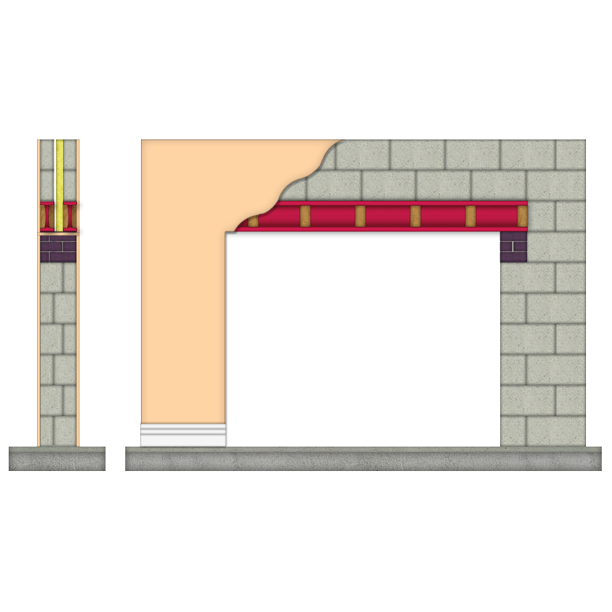

Material

Extension
Structural Opening to New Wall (Front FF wall support)
Lintel Number 1 | Universal Beam 203 x 102 x 30kg per m | 2.7 m
Lintel Number 2 | Universal Beam 203 x 102 x 30kg per m | 2.7 m
Padstones to support steelwork | Concrete Padstone 440x140x215mm | 2 Each
Slates to pack steelwork | Natural Slate 400 x 250mm (Each) (Allowance £1.50) | 4 Each
Noggings to steelwork | Sawn Softwood Kiln Dried Treated 47.0 x 50mm | 2.1 Metre

House
Small Structural Opening (Opening in cavity wall)
Lintel Number 1 | Prestressed Concrete Lintel 100 x 140 x 1050mm | 1.1 Each
Lintel Number 2 | Prestressed Concrete Lintel 100 x 140 x 1050mm | 1.1 Each

Labour

Extension
Structural Opening to New Wall (Front FF wall support)
Form opening | Bricklayer | 2 Hours
Form opening | Bricklayers Labourer | 2 Hours
Fix lintels | Bricklayer | 3 Hours
Fix lintels | Bricklayers Labourer | 3 Hours

House
Small Structural Opening (Opening in cavity wall)
Remove spoil from structural opening | 2 Bricklayers and Mate | 1 Hours
Form opening | Bricklayer | 4 Hours
Form opening | Bricklayers Labourer | 4 Hours
Fix lintels | Bricklayer | 1 Hours
Fix lintels | Bricklayers Labourer | 1 Hours

Plant

House
Small Structural Opening (Opening in cavity wall)
Plant to remove spoil from site | Skip 7m3 inc. Land Fill Tax | 0.16 Each
Plant for propping structural opening | Acrow Props 1, 2 & 3 | 1 Week
Plant for removing spoil from structural opening | Wheelbarrow | 0.2 Week
Plant for forming structural opening | Disc Cutter 12" Petrol | 0.2 Week
Plant for forming structural opening | Shovel | 0.2 Week

Total Cost Excluding VAT £972.57

Roof Tiling  Lay roof covering. | 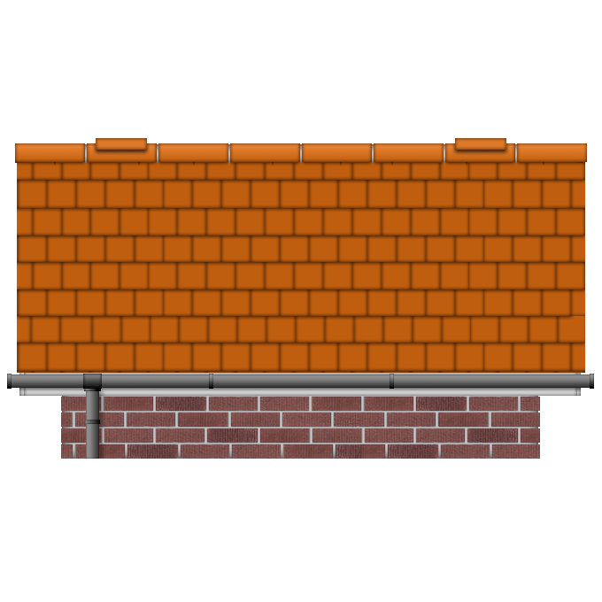

Material

Extension
Apex Truss Roof (Main roof)
Lathe | Sawn Batten Treated 25.0 x 38mm | 125 Metre
Lathe nails | Round Wire Nails Galvanised 65mm x 25kg | 0.09 Box
Roofing felt | Breather Membrane 700 1.5 x 50 m | 0.36 Each
Tiles | Roof Tile Concrete Interlocking Low Profile Each (10 per m2 approx.) (Allowance £1.50 each) | 241 Each
Tile Nails | Round Wire Nails Galvanised 65mm x 25kg | 0.04 Box
Ridge tile | Segmental Ridge Tile 457mm | 6 Each
Tile undercloak 1 | Cement Soffit Strip 2400 x 150 x 4.5mm | 3.6 Each
Sand pointing/bedding to ridge | Building Sand Bulk Bag | 0.03 Each
Sand pointing/bedding to verge | Building Sand Bulk Bag | 0.18 Each
Cement in pointing/bedding to ridge | Blue Circle Mastercrete Original Cement 25kg Bag | 0.31 Each
Cement pointing/bedding to verge | Blue Circle Mastercrete Original Cement 25kg Bag | 2 Each
Lean to Roof (lean to roof)
Lathe | Sawn Batten Treated 25.0 x 38mm | 21 Metre
Lathe nails | Round Wire Nails Galvanised 65mm x 25kg | 0.01 Box
Roofing felt | Breather Membrane 700 1.5 x 50 m | 0.06 Each
Tiles | Roof Tile Concrete Interlocking Low Profile Each (10 per m2 approx.) | 39 Each
Tile Nails | Round Wire Nails Galvanised 65mm x 25kg | 0.01 Box
Lean to roof ridge tile or flashing | LEAD Flashing Code 4 - 3m x 300mm | 1 Roll
Lean to roof cavity tray | Horizontal Cavity Tray 440mm | 6.9 Each
Tile undercloak 1 | Cement Soffit Strip 2400 x 150 x 4.5mm | 0.53 Each
Tile undercloak 2 | Cement Soffit Strip 2400 x 150 x 4.5mm | 0.53 Each
Sand pointing/bedding to ridge | Building Sand Bulk Bag | 0.03 Each
Sand pointing/bedding to verge | Building Sand Bulk Bag | 0.03 Each
Cement in pointing/bedding to ridge | Blue Circle Mastercrete Original Cement 25kg Bag | 0.35 Each
Cement pointing/bedding to verge | Blue Circle Mastercrete Original Cement 25kg Bag | 0.3 Each

Labour

Extension
Apex Truss Roof (Main roof)
Fix tiles, felt and lathe. | 3 Roof tilers + mate | 7 Hours
Fix verge tiles | Roof tiler | 1 Hours
Fix ridge tile | Roof tiler + mate | 1 Hours
Fix tile undercloak 1 | Roof tiler | 1 Hours
Lean to Roof (lean to roof)
Fix tiles, felt and lathe. | 3 Roof tilers + mate | 1 Hours
Fix verge tiles | Roof tiler | 1 Hours
Fix Lean to roof ridge tile or flashing | Roof tiler + mate | 2 Hours
Fix tile undercloak 1 | Roof tiler | 1 Hours
Fix tile undercloak 2 | Roof tiler | 1 Hours

Total Cost Excluding VAT £1,834.75

Joinery 1st Fix  Form carcassing and first fix timbers. | 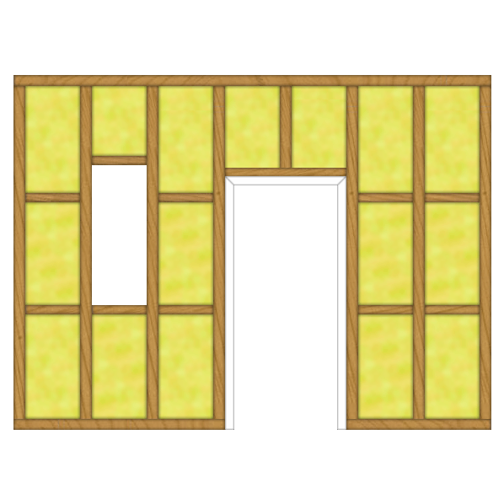

Material

Extension
Stud Wall (internal stud walls)
Vertical studding | Sawn Dry Graded Structural Softwood Treated 47.0 x 100mm | 30 Metre
Horizontal rails (noggings) | Sawn Dry Graded Structural Softwood Treated 47.0 x 100mm | 4.8 Metre
Head runner | Sawn Dry Graded Structural Softwood Treated 47.0 x 100mm | 4.8 Metre
Sole plate | Sawn Dry Graded Structural Softwood Treated 47.0 x 100mm | 3.1 Metre
Nailing allowance to studding | Round Wire Nails Bright 100mm x 25kg | 0.16 Box
Suspended Floor (suspended floor)
Floor Boards | V313 T & G Chipboard 2400x600 x 19mm | 10 Each
Nailing to floorboards | Lost Head Round Wire Nails Bright 65mm x 25kg | 0.12 Box
fix pole plate to ex. wall | Rawlbolt M12 | 11 Each

House
PVCu Windows 1050 Deep (110 C 600 x 1050 window)
Window fixings to sides | Hammer in Fixing 8mm x 100mm (12 Bag) | 0.5 Pack
Window fixings to top and bottom | Wood Screws Steel CSK Twin Thread 10 x 3 inch (100 box) | 0.04 Box
Internal window board | Window Board 25 x 219mm | 0.7 Metre
Fixings to window board | Wood Screws Steel CSK Twin Thread 10 x 3 inch (100 box) | 0.02 Box
Window | 110C PVC Window Clear Low E Glass 600 x 1050mm | 1 Each
PVCu Windows 1200 Deep (212C 1200 x 1200 window)
Window fixings to sides | Hammer in Fixing 8mm x 100mm (12 Bag) | 0.67 Pack
Window fixings to top and bottom | Wood Screws Steel CSK Twin Thread 10 x 3 inch (100 box) | 0.08 Box
Internal window board | Window Board 25 x 219mm | 1.3 Metre
Fixings to window board | Wood Screws Steel CSK Twin Thread 10 x 3 inch (100 box) | 0.04 Box
Window | 212C PVC Window Clear Low E Glass 1200 x 1200mm | 1 Each

Upstairs
Typical Panel Doors (762 Door into Studding)
Door casing fixings to sides | Cut Clasp Nails 75mm x 25kg
Door casing fixings | Cut Clasp Nails 75mm x 25kg
Door casing | Unprimed 115 x 32mm Door Lining Set No Stops 5100mm | 2 Each

Labour

Extension
Stud Wall (internal stud walls)
Fix studding | Joiner + Mate | 2 Hours
Fix horizontal rails (noggings) | Joiner + Mate | 1 Hours
Fix head runner | Joiner + Mate | 1 Hours
Fix sole plate | Joiner + Mate | 1 Hours
Suspended Floor (suspended floor)
Fix floorboarding | Joiner + Mate | 4 Hours
fix pole plate to ex. wall | Joiner + Mate | 2 Hours

House
PVCu Windows 1050 Deep (110 C 600 x 1050 window)
Fix internal window board | Joiner | 1 Hours
Fix window | Joiner | 1 Hours
Fix glazing | Joiner | 1 Hours
PVCu Windows 1200 Deep (212C 1200 x 1200 window)
Fix internal window board | Joiner | 1 Hours
Fix window | Joiner | 1 Hours
Fix glazing | Joiner | 1 Hours

Upstairs
Typical Panel Doors (762 Door into Studding)
Fix door casing | Joiner | 2 Hours
Typical Panel Doors (864 Door into Studding)
Fix door casing | Joiner | 5 Hours

Total Cost Excluding VAT £1,588.07

Plastering  Apply plastering system to walls and ceilings. | 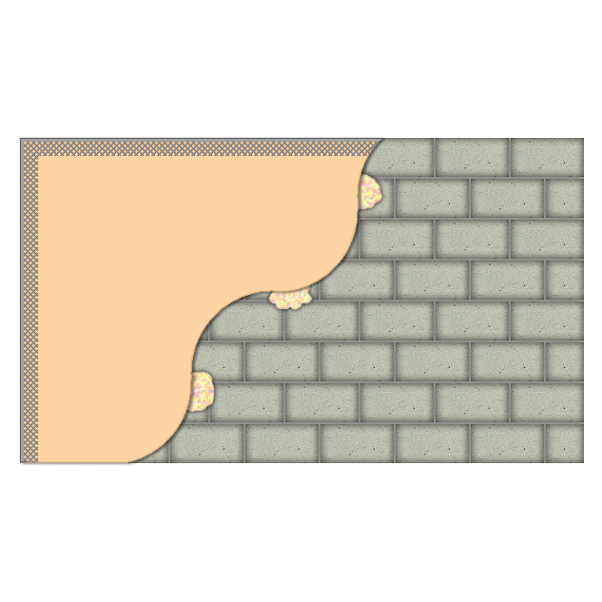

Material

Extension
Apex Truss Roof (Main roof)
Plasterboard to roof ceilings | Plasterboard Square Edge 1200 x 2400 x 12.5mm | 5.3 Sheet
Plasterboard fixings for roof ceilings | Drywall Timber Screws 41mm 1000 box | 0.15 Box
Plasterboard joint treatment for roof ceilings | Plasterboard Tape 50mm x 90m | 0.3 Each
Finish to plasterboard for roof ceilings | Board Finish Plaster 25kg | 1.3 Each
Insulation to ceiling (layer 1) | GP fibreglass insulation Roll 150mm 6.99m2 | 2.3 Each
Insulation to ceiling (layer 2) | GP fibreglass insulation Roll 150mm 6.99m2 | 2.3 Each
External Cavity Block Wall (external walls)
Plastering to inner blockwall | Plasterboard Square Edge 1200 x 2400 x 12.5mm | 11 Sheet
Wall plastering fixing system / basecoat | Plasterboard Adhesive 25kg | 3.7 Each
Wall plastering joint treatment | Plasterboard Tape 50mm x 90m | 0.61 Each
Plaster finish to walls | Board Finish Plaster 25kg | 2.7 Each
Render/Plaster to outer blockwall | Plastering Sand Bulk Bag | 1.2 Each
Outer blockwork finish fixing system / base | Blue Circle Mastercrete Original Cement 25kg Bag | 14 Each
Lean to Roof (lean to roof)
Plasterboard to roof ceilings | Plasterboard Square Edge 1200 x 2400 x 12.5mm | 0.46 Sheet
Plasterboard fixings for roof ceilings | Drywall Timber Screws 41mm 1000 box | 0.01 Box
Plasterboard joint treatment for roof ceilings | Plasterboard Tape 50mm x 90m | 0.03 Each
Finish to plasterboard for roof ceilings | Board Finish Plaster 25kg | 0.12 Each
Insulation to ceiling (layer 1) | GP fibreglass insulation Roll 150mm 6.99m2 | 0.34 Each
Insulation to ceiling (layer 2) | GP fibreglass insulation Roll 150mm 6.99m2 | 0.34 Each
Structural Opening to New Wall (Front FF wall support)
Reveal plaster finish to structural opening | Fire Protective Plasterboard Square Edge 1200 x 2400 x 12.5mm | 0.69 Sheet
Reveal plastering fixing system / basecoat to opening | Plasterboard Adhesive 25kg | 0.24 Each
Reveal plaster joint treatment structural opening | Plasterboard Tape 50mm x 90m | 0.04 Each
Reveal finish to plaster structural opening | Board Finish Plaster 25kg | 0.18 Each
Corner Bead to structural opening reveal | PVC Plastering Corner Bead 2.44m | 5.5 Each
Stud Wall (internal stud walls)
Plasterboard to side 1 of stud wall | Plasterboard Square Edge 1200 x 2400 x 12.5mm | 2.8 Sheet
Plaster fixings to side 1 of stud wall | Drywall Timber Screws 41mm 1000 box | 0.08 Box
Plaster joint treatment to side 1 of stud wall | Plasterboard Tape 50mm x 90m | 0.16 Each
Finish to plaster to side 1 of stud wall | Board Finish Plaster 25kg | 0.72 Each
Insulation to stud wall | 50mm rockwool flexi slab (5.76m2 per pack) | 1.4 Each
Plasterboard to side 2 of stud wall | Plasterboard Square Edge 1200 x 2400 x 12.5mm | 2.8 Sheet
Plaster fixings to side 2 of stud wall | Drywall Timber Screws 41mm 1000 box | 0.08 Box
Plaster joint treatment to side 2 of stud wall | Plasterboard Tape 50mm x 90m | 0.16 Each
Finish to plaster to side 2 of stud wall | Board Finish Plaster 25kg | 0.72 Each
Suspended Floor (suspended floor)
Plasterboard to floor ceilings | Plasterboard Square Edge 1200 x 2400 x 12.5mm | 5.2 Sheet
Plaster fixings to floor ceilings | Drywall Timber Screws 41mm 1000 box | 0.15 Box
Plaster joint treatment to floor ceilings | Plasterboard Tape 50mm x 90m | 0.3 Each
Finish to plaster to floor ceilings | Board Finish Plaster 25kg | 1.3 Each
Insulation to floors | 100mm rockwool flexi slab (4.32m2 per pack) | 3.7 Each

House
Brick and Block Cavity Wall (ext. walls)
Plaster finish to walls | Board Finish Plaster 25kg | 0.43 Each
Plastering to inner blockwall | Plasterboard Square Edge 1200 x 2400 x 12.5mm | 1.7 Sheet
Wall plastering fixing system / basecoat | Plasterboard Adhesive 25kg | 0.58 Each
Wall plastering joint treatment | Plasterboard Tape 50mm x 90m | 0.1 Each
PVCu Windows 1050 Deep (110 C 600 x 1050 window)
Reveal and cill plaster finish to window | Plasterboard Square Edge 1200 x 2400 x 12.5mm | 0.14 Sheet
Window reveal & cill plaster fixing system / base coat | Plasterboard Adhesive 25kg | 0.05 Each
Window reveal and cill plaster joint treatment | Plasterboard Tape 50mm x 90m | 0.01 Each
Window reveal and cill finish to plaster | Board Finish Plaster 25kg | 0.04 Each
Window reveal corner bead | PVC Plastering Corner Bead 2.44m | 1.1 Each
PVCu Windows 1200 Deep (212C 1200 x 1200 window)
Reveal and cill plaster finish to window | Plasterboard Square Edge 1200 x 2400 x 12.5mm | 0.19 Sheet
Window reveal & cill plaster fixing system / base coat | Plasterboard Adhesive 25kg | 0.06 Each
Window reveal and cill plaster joint treatment | Plasterboard Tape 50mm x 90m | 0.01 Each
Window reveal and cill finish to plaster | Board Finish Plaster 25kg | 0.05 Each
Window reveal corner bead | PVC Plastering Corner Bead 2.44m | 1.5 Each
Small Structural Opening (Opening in cavity wall)
Reveal plaster finish to structural opening | Fire Protective Plasterboard Square Edge 1200 x 2400 x 12.5mm | 0.53 Sheet
Reveal plastering fixing system / basecoat to opening | Plasterboard Adhesive 25kg | 0.18 Each
Reveal plaster joint treatment structural opening | Plasterboard Tape 50mm x 90m | 0.03 Each
Reveal finish to plaster structural opening | Board Finish Plaster 25kg | 0.14 Each
Corner Bead to structural opening reveal | PVC Plastering Corner Bead 2.44m | 4.3 Each

Labour

Extension
Apex Truss Roof (Main roof)
Fix plasterboard to roof ceilings | 2 Plasterers and 1 Plasterers Mate | 2 Hours
Apply finish to ceiling plaster to roofs | 2 Plasterers and 1 Plasterers Mate | 3 Hours
Fix insulation to ceiling (layer 1) | Insulation Specialist | 1 Hours
Fix insulation to ceiling (layer 2) | Insulation Specialist | 1 Hours
External Cavity Block Wall (external walls)
Apply finish to wall plastering | 2 Plasterers and 1 Plasterers Mate | 5 Hours
Fix/apply plastering to walls | 2 Plasterers and 1 Plasterers Mate | 4 Hours
Apply finish to outer wall rendering | 2 Plasterers and 1 Plasterers Mate | 5 Hours
Apply rendering to outer walls | 2 Plasterers and 1 Plasterers Mate | 9 Hours
Lean to Roof (lean to roof)
Fix plasterboard to roof ceilings | 2 Plasterers and 1 Plasterers Mate | 1 Hours
Apply finish to ceiling plaster to roofs | 2 Plasterers and 1 Plasterers Mate | 1 Hours
Fix insulation to ceiling (layer 1) | Insulation Specialist | 1 Hours
Fix insulation to ceiling (layer 2) | Insulation Specialist | 1 Hours
Structural Opening to New Wall (Front FF wall support)
Fix structural opening reveal plaster | 2 Plasterers and 1 Plasterers Mate | 1 Hours
Apply finish to structural opening reveal plaster | 2 Plasterers and 1 Plasterers Mate | 1 Hours
Stud Wall (internal stud walls)
Fix plasterboard to side 1 | 2 Plasterers and 1 Plasterers Mate | 1 Hours
Apply finish to plaster to side 1 | 2 Plasterers and 1 Plasterers Mate | 2 Hours
Fix insulation | Plasterers Mate | 1 Hours
Fix plasterboard to side 2 | 2 Plasterers and 1 Plasterers Mate | 1 Hours
Apply finish to plaster to side 2 | 2 Plasterers and 1 Plasterers Mate | 2 Hours
Suspended Floor (suspended floor)
Fix plasterboard to floor ceilings | 2 Plasterers and 1 Plasterers Mate | 2 Hours
Apply finish to plaster to floors | 2 Plasterers and 1 Plasterers Mate | 3 Hours
Fix floor insulation | General Labourer | 2 Hours

House
Brick and Block Cavity Wall (ext. walls)
Fix/apply plastering to walls | 2 Plasterers and 1 Plasterers Mate | 1 Hours
Apply finish to wall plastering | 2 Plasterers and 1 Plasterers Mate | 1 Hours
PVCu Windows 1050 Deep (110 C 600 x 1050 window)
Fix window reveal and cill plastering | 2 Plasterers and 1 Plasterers Mate | 1 Hours
Apply window reveal and cill finish to plaster | 2 Plasterers and 1 Plasterers Mate | 1 Hours
PVCu Windows 1200 Deep (212C 1200 x 1200 window)
Fix window reveal and cill plastering | 2 Plasterers and 1 Plasterers Mate | 1 Hours
Apply window reveal and cill finish to plaster | 2 Plasterers and 1 Plasterers Mate | 1 Hours
Small Structural Opening (Opening in cavity wall)
Fix structural opening reveal plaster | 2 Plasterers and 1 Plasterers Mate | 1 Hours
Apply finish to structural opening reveal plaster | 2 Plasterers and 1 Plasterers Mate | 1 Hours

Total Cost Excluding VAT £3,840.91

Joinery 2nd Fix  Fix doors and windows, fixtures and fittings. | 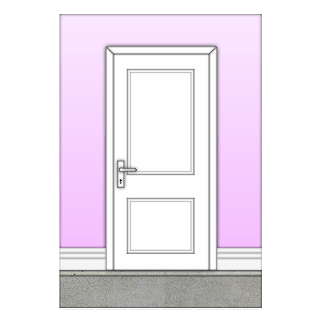

Material

Extension
External Cavity Block Wall (external walls)
Skirting boards | Skirting Torus/Ovolo 19 x 125mm (Redwood) | 10 Metre
Fixings to skirtings | Cut Clasp Nails 65mm x 25kg | 0.02 Box
Stud Wall (internal stud walls)
Skirting board side 1 of stud wall | Skirting Torus/Ovolo 19 x 125mm (Redwood) | 3.1 Metre
Skirting board side 2 of stud wall | Skirting Torus/Ovolo 19 x 125mm (Redwood) | 3.1 Metre
Suspended Floor (suspended floor)
Perimeter floor sealant | Acoustic Floor Sealant 380ml | 2.1 Each

House
Brick and Block Cavity Wall (ext. walls)
Skirting boards | Skirting Torus/Ovolo 19 x 125mm (Redwood) | 2.6 Metre
Fixings to skirtings | Cut Clasp Nails 65mm x 25kg
PVCu Windows 1050 Deep (110 C 600 x 1050 window)
Sealant to sides and top of window | Silicone Sealant White 0.31 Litre | 0.1 Each
PVCu Windows 1200 Deep (212C 1200 x 1200 window)
Sealant to sides and top of window | Silicone Sealant White 0.31 Litre | 0.14 Each

Upstairs
Typical Panel Doors (762 Door into Studding)
Architrave | Torus Architrave 25 x 75mm (Redwood) | 20 Metre
Fixings to architrave | Panel Pins Bright 40mm x 0.25kg | 0.72 Each
Door | Internal Door 4 Panel Solid Oak 686mm x 1981mm | 2 Each
Door furniture | Georgian Brass Internal Latch Pack | 2 Each
Hinges | Butt Hinge Brassed 76mm | 3 Pair
Typical Panel Doors
Door | Internal Door 4 Panel Solid Oak 762mm x 1981mm | 6 Each
Door furniture | Georgian Brass Internal Latch Pack | 6 Each
Hinges | Butt Hinge Brassed 76mm | 9 Pair

Labour

Extension
External Cavity Block Wall (external walls)
Fix skirting boards | Joiners Mate | 3 Hours
Stud Wall (internal stud walls)
Fix skirting board to side 1 | Joiners Mate | 1 Hours
Fix skirting board to side 2 | Joiners Mate | 1 Hours
Suspended Floor (suspended floor)
Apply perimeter floor sealant | Joiners Mate | 4 Hours

House
Brick and Block Cavity Wall (ext. walls)
Fix skirting boards | Joiners Mate | 1 Hours
PVCu Windows 1050 Deep (110 C 600 x 1050 window)
Apply sealant to sides and top of window | Joiner | 1 Hours
PVCu Windows 1200 Deep (212C 1200 x 1200 window)
Apply sealant to sides and top of window | Joiner | 1 Hours

Upstairs
Typical Panel Doors (762 Door into Studding)
Fix architrave | Joiners Mate | 4 Hours
Hang door | Joiner | 2 Hours
Fix door furniture | Joiner | 2 Hours
Typical Panel Doors
Hang door | Joiner | 6 Hours
Fix door furniture | Joiner | 5 Hours

Total Cost Excluding VAT £2,481.47

Internal Decoration  Apply decoration. (Note that a basic paint specification has been used for the purposes of estimating the building works. However, colours and finishes may be changed by agreement in writing.) | 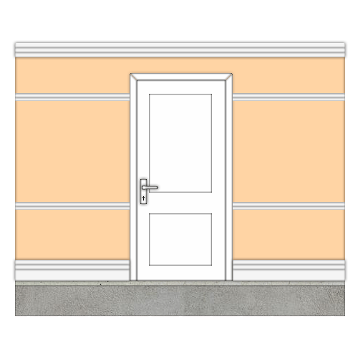

Material

Extension
Apex Truss Roof (Main roof)
Decoration to plaster roof ceiling | Contract Emulsion Brilliant White 5 Litre | 0.53 Each
External Cavity Block Wall (external walls)
Decoration to wall or plaster | Contract Emulsion Magnolia 5 Litre | 1.1 Each
Primer for skirting boards | Undercoat White 5 Litre | 0.03 Each
Under Coat for skirting boards | Undercoat White 5 Litre | 0.03 Each
Paint for skirting boards | Gloss Brilliant White 5 Litre | 0.03 Each
Lean to Roof (lean to roof)
Decoration to plaster roof ceiling | Contract Emulsion Brilliant White 5 Litre | 0.05 Each
Structural Opening to New Wall (Front FF wall support)
Decoration to structural opening reveal plastering | Contract Emulsion Magnolia 5 Litre | 0.07 Each
Stud Wall (internal stud walls)
Decoration to plaster to side 1 of stud wall | Contract Emulsion Magnolia 5 Litre | 0.28 Each
Decoration to plaster to side 2 of stud wall | Contract Emulsion Magnolia 5 Litre | 0.28 Each
Priming to skirting board side 1 of stud wall | Undercoat White 5 Litre | 0.01 Each
Undercoating to skirting board side 1 of stud wall | Undercoat White 5 Litre | 0.01 Each
Finishing coat to skirting board side 1 of stud wall | Gloss Brilliant White 5 Litre | 0.01 Each
Priming to skirting board side 2 of stud wall | Undercoat White 5 Litre | 0.01 Each
Undercoating to skirting board side 2 of stud wall | Undercoat White 5 Litre | 0.01 Each
Finishing coat to skirting board side 2 of stud wall | Gloss Brilliant White 5 Litre | 0.01 Each
Suspended Floor (suspended floor)
Decoration to plaster | Contract Emulsion Brilliant White 5 Litre | 0.52 Each

House
Brick and Block Cavity Wall (ext. walls)
Decoration to wall or plaster | Contract Emulsion Magnolia 5 Litre | 0.17 Each
Primer for skirting boards | Undercoat White 5 Litre | 0.01 Each
Under Coat for skirting boards | Undercoat White 5 Litre | 0.01 Each
Paint for skirting boards | Gloss Brilliant White 5 Litre | 0.01 Each
PVCu Windows 1050 Deep (110 C 600 x 1050 window)
Window decoration to reveal plastering | Contract Emulsion Magnolia 5 Litre | 0.01 Each
Primer for window board | Undercoat White 5 Litre | 0.01 Each
Undercoat for window board | Undercoat White 5 Litre | 0.01 Each
Paint for window board | Gloss Brilliant White 5 Litre | 0.01 Each
PVCu Windows 1200 Deep (212C 1200 x 1200 window)
Window decoration to reveal plastering | Contract Emulsion Magnolia 5 Litre | 0.02 Each
Primer for window board | Undercoat White 5 Litre | 0.01 Each
Undercoat for window board | Undercoat White 5 Litre | 0.01 Each
Paint for window board | Gloss Brilliant White 5 Litre | 0.01 Each
Small Structural Opening (Opening in cavity wall)
Decoration to structural opening reveal plastering | Contract Emulsion Magnolia 5 Litre | 0.05 Each

Upstairs
Typical Panel Doors (762 Door into Studding)
Primer for architrave | Undercoat White 5 Litre | 0.06 Each
Undercoat for architrave | Undercoat White 5 Litre | 0.06 Each
Paint for architrave | Gloss Brilliant White 5 Litre | 0.06 Each
Primer for door casing | Undercoat White 5 Litre | 0.05 Each
Undercoat for door casing | Undercoat White 5 Litre | 0.1 Each
Paint for door casing | Gloss Brilliant White 5 Litre | 0.05 Each
Typical Panel Doors (864 Door into Studding)
Primer for architrave | Undercoat White 5 Litre | 0.18 Each
Undercoat for architrave | Undercoat White 5 Litre | 0.18 Each
Paint for architrave | Gloss Brilliant White 5 Litre | 0.18 Each

Labour

Extension
Apex Truss Roof (Main roof)
Prepare roof ceiling for decoration | Decorator | 1 Hours
Decorate ceiling plaster | Decorator | 2 Hours
External Cavity Block Wall (external walls)
Prepare wall or plaster for decoration | Decorator | 2 Hours
Apply decoration to wall or plaster | Decorator | 4 Hours
Prepare skirting boards for decoration | Decorator | 1 Hours
Apply primer to skirting boards | Decorator | 1 Hours
Apply undercoat to skirting boards | Decorator | 1 Hours
Apply paint to skirting boards | Decorator | 1 Hours
Lean to Roof (lean to roof)
Prepare roof ceiling for decoration | Decorator | 1 Hours
Decorate ceiling plaster | Decorator | 1 Hours
Structural Opening to New Wall (Front FF wall support)
Prepare plaster structural opening reveals for decoration | Decorator | 1 Hours
Apply decoration to plaster structural opening reveals | Decorator | 1 Hours
Stud Wall (internal stud walls)
Decorate plaster to side 1 | Decorator | 1 Hours
Decorate plaster to side 2 | Decorator | 1 Hours
Prepare skirting for priming/painting 1 | Decorator | 1 Hours
Apply primer to skirting to side 1 | Decorator | 1 Hours
Apply undercoat to skirting to side 1 | Decorator | 1 Hours
Apply finishing to skirting to side 1 | Decorator | 1 Hours
Prepare skirting for priming/painting 2 | Decorator | 1 Hours
Apply primer to skirting to side 2 | Decorator | 1 Hours
Apply undercoat to skirting to side 2 | Decorator | 1 Hours
Apply finishing to skirting to side 2 | Decorator | 1 Hours
Suspended Floor (suspended floor)
Prepare floor ceilings for decoration | Decorator | 1 Hours
Decorate plaster to floor ceilings | Decorator | 2 Hours

House
Brick and Block Cavity Wall (ext. walls)
Prepare wall or plaster for decoration | Decorator | 1 Hours
Apply decoration to wall or plaster | Decorator | 1 Hours
Prepare skirting boards for decoration | Decorator | 1 Hours
Apply primer to skirting boards | Decorator | 1 Hours
Apply undercoat to skirting boards | Decorator | 1 Hours
Apply paint to skirting boards | Decorator | 1 Hours
PVCu Windows 1050 Deep (110 C 600 x 1050 window)
Prepare window plaster reveals for decoration | Decorator | 1 Hours
Apply decoration to window plaster reveals and cill | Decorator | 1 Hours
Prepare window board for decoration | Decorator | 1 Hours
Apply primer for window board | Decorator | 1 Hours
Apply undercoat for window board | Decorator | 1 Hours
Apply paint for window board | Decorator | 1 Hours
PVCu Windows 1200 Deep (212C 1200 x 1200 window)
Prepare window plaster reveals for decoration | Decorator | 1 Hours
Apply decoration to window plaster reveals and cill | Decorator | 1 Hours
Prepare window board for decoration | Decorator | 1 Hours
Apply primer for window board | Decorator | 1 Hours
Apply undercoat for window board | Decorator | 1 Hours
Apply paint for window board | Decorator | 1 Hours
Small Structural Opening (Opening in cavity wall)
Prepare plaster structural opening reveals for decoration | Decorator | 1 Hours
Apply decoration to plaster structural opening reveals | Decorator | 1 Hours

Upstairs
Typical Panel Doors (762 Door into Studding)
Prepare door casing for decoration | Decorator | 2 Hours
Apply primer to door casing | Decorator | 2 Hours
Apply undercoat to door casing | Decorator | 2 Hours
Apply paint to door casing | Decorator | 2 Hours

Total Cost Excluding VAT £597.17

External Decoration  Apply decoration. (Note that a basic paint specification has been used for the purposes of estimating the building works. However, colours and finishes may be changed by agreement in writing.) | 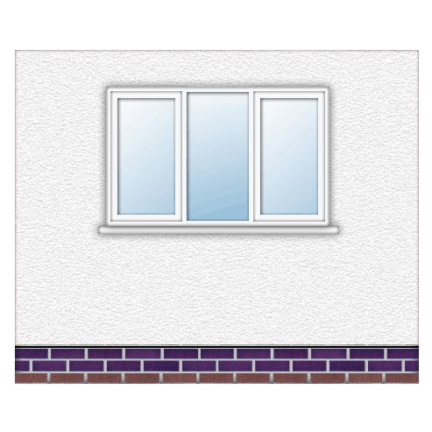

Material

Extension
External Cavity Block Wall (external walls)
Decoration to wall finish outer leaf | Smooth Masonry Paint Brilliant White 10 Litre | 0.56 Each

Labour

Extension
External Cavity Block Wall (external walls)
Prepare outer wall or render for decoration | Decorator | 2 Hours
Apply decoration to outer wall or render | Decorator | 7 Hours

Total Cost Excluding VAT £205.48

Completion

Completion of all building works.

Labour

Upstairs
Typical Panel Doors (762 Door into Studding)
Return to ease door | Joiner | 1 Hours
Typical Panel Doors (864 Door into Studding)
Return to ease door | Joiner | 3 Hours

Total Cost Excluding VAT £104.00

Provisional & P.C. Sums

The following items are either shown or specified with insufficient detail to accurately estimate and are therefore covered by the following Provisional & P.C. Sums

Electrical works £ 1,500.00
Heating and plumbing works £ 2,000.00
Supply of sanitary-ware to ensuite £ 500.00
Supply of sanitary-ware to family bathroom £ 500.00
Supply and fix ceramic wall tiling £ 1,000.00
Re-decoration of existing external render to match new £ 500.00

Total Provisional & P.C. Sums £ 6,000.00

Please note:

- No decoration has been allowed for the existing bedrooms.
- No allowance has been made for floor finishes.

Total Cost Excluding VAT £27,765.51
Total VAT £ 5,553.10
Total Cost Including VAT £33,318.61

Acceptance of Estimate

Reference: Extension

Mr & Mrs Smith
Beaconstone
Hillcommon
Somerset
TA4 1DU

Site address:
1 Station Road
Ilton
Somerset
TA19 9BZ

Please carry out the building works itemised in the Estimate defined above, dated Tuesday, 1st November 2016 to the value of:

Total Cost Excluding VAT £27,765.51
Total VAT £ 5,553.10
Total Cost Including VAT £33,318.61

Signed Mr & Mrs Smith | ………………………….
Date | ……/………/20………..
Signed on behalf of “YOUR COMPANY NAME” | ………………………….
Date | ……/………/20………..

Acceptance of Estimate

Reference: Extension

Mr & Mrs Smith
Beaconstone
Hillcommon
Somerset
TA4 1DU

Site address:
1 Station Road
Ilton
Somerset
TA19 9BZ

Please carry out the building works itemised in the Estimate defined above, dated Tuesday, 1st November 2016 to the value of:

Total Cost Excluding VAT £27,765.51
Total VAT £ 5,553.10
Total Cost Including VAT £33,318.61

Signed Mr & Mrs Smith | ………………………….
Date | ……/………/20………..
Signed on behalf of “YOUR COMPANY NAME” | ………………………….
Date | ……/………/20………..

